Starlite Project Installation and Setup

# Introduction:

Welcome to the Starlite project. Whether you’re planning to build the 6 or 8 point star, the follow information will help you on your way.

# Build Tools:

The design was built using the Lattice Semiconductor iCEcube2 platform. There are other tools one could use, but that would require significant changes to the supplied code. iCEcube2 is free and is available on the Lattice website at:

<http://www.latticesemi.com/Products/DesignSoftwareAndIP/FPGAandLDS/iCEcube2>

You’ll find useful documentation on that web page. The “iCEcube2_install_overview” document has important installation and license information. A license is required to run iCEcube2. The link to obtaining a license is also at the above website. Follow the license link. You’ll be asked to sign in to your account. If you don’t have one, you’ll need to create by selecting the “Create Account” link.

Once a license is obtained, download and install iCEcube2.

# Creating a Project:

Start the iCEcube2 software. The iCECube2 main window appears, as shown in Figure 1.



Figure 1: iCEcube2 Main Window

To create a new project, choose File > New, or click the Create a New Project icon as shown in Figure 1. This will launch the New Project Wizard, as shown in Figure 2. Make the changes indicated (in Figure 2) to the Project, Device and IO Bank Voltage sections.

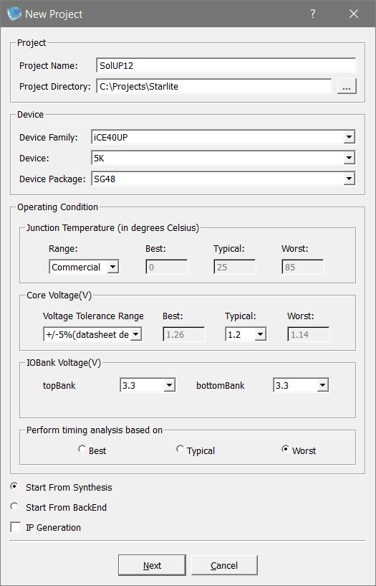

Figure 2: New Project Wizard

Click Next to display the Add Files dialog box.

Select Finish (we’ll add the files later).